 | Student Name _______________________  Eastern Goldfields College  Mathematics Specialist 2015  Investigation 1 - Part A
There are two parts to this investigation. Part A is a take-home assignment, of which you have one week to complete. You will be able to use your answers to Part A while completing Part B.
Part A is worth 6 marks.


Part B is an in-class investigation which is worth 26 marks. Completing Part A of this investigation will significantly help you in doing Part B.

Date of submission and Part B: Thursday 19th March

Moth Spirals
A theory about moth navigation is that a moth flies at a constant
angle relative to any light source in the same horizontal plane.

A moth flies at 50° to the light source L and measures its bearing and re-corrects its path 10 times in every revolution.

β
Cº

R₁


Aº
Bº
50º
R₀
L
Angle of attack
1. Determine the size of each angle, A, B and C.

2. Show that R₁ is equal to R₀ 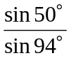.

3. Find R₃ exactly in terms of R₀.

Investigate further.

What happens if the angle of attack is different?
What happens if the bearing is measured less than 10 times per revolution?
How do the triangles in the diagram above relate to each other?

Student Name _______________________

Eastern Goldfields College
Mathematics Specialist 2015
Investigation 1 - Part B
Working Time: 40 minutes | Total Marks: 26 marks

You are NOT allowed to use Part A when completing Part B.

Answer all of the following questions. Show all working to obtain full marks.

A moth flies at 50° to the light source L and measures its bearing and re-corrects its path 10 times in every revolution.

R₀
R₁
L
Aº
Bº
50º
Cº
Angle of attack
β

1. [4 marks]
a) Showing full working, produce a formula in exact terms for R₁₀ in terms of R₀.

b) Produce a formula in exact terms for R_{n} in terms of R₀.

2. [3 marks]
a) From the details given in Part A, describe the flight path of the moth.

b) Let R₀ = 20 cm. Complete the graph below for the first six R calculations.
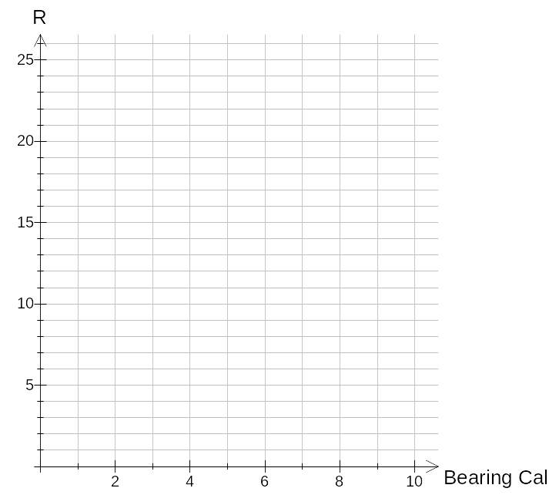

3. [5 marks]
a) From the details given in Part A, determine θ , the ‘angle of attack’ which will produce
a circular flight path.

b) For what values of θ will the moth spiral inwards/outwards?

4. [2 marks]
From the details given in Part A, describe with reasoning what happens when the bearing is re-calculated 5 times instead of 10 times per revolution.

5. [2, 1, 2 marks]
a) A second moth again flies with θ = 50° but measures its bearing x times in one
revolution. What is the formula for R_{n} now?

- Generalise your formula for a moth which flies at a constant bearing of θ° to the light
source and measures its bearing x times in one revolution.

c) Describe, with reasoning, the flight path for a moth where θ = 65° and x = 8.

6. [1, 1, 3, 2 marks]
Here are graphs of two moths flying where they re-measure their bearing 6 times every
revolution. R is the distance in metres measured from a very bright light source.
Moth 1 111
Moth 22

a) How far away from the light source was Moth 2 initially ?

b) The ‘angles of attack’ are 70° and 40°. Identify the ‘angle of attack’ for
each moth.

c) Calculate the next two R values for Moth 2, write them down here and
then plot them on the graph above.

d) A third moth is initially 20 metres from the light source with an ‘angle of
attack’ of 60°. Comment with reasoning on the flight path of this moth.

Moth Spirals VALIDATION SOLUTIONS
Total marks 32

PART A ANSWERS [6 marks]

1. Aº = Bº = 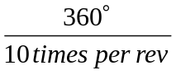 = 36º Cº = ‘angle of attack’ = 50º


2. 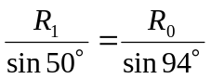 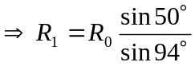


3. 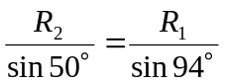 Now 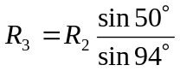

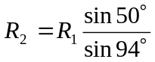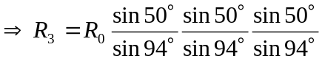


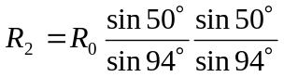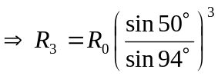



Evidence of further research :

PART B [26 marks] Part A may be referred to when answering Part B

A moth flies at 50° to the light source L and measures its bearing and re-corrects its path 10 times in every revolution.

1. [4 marks]
a) Showing full working, produce a formula in exact terms for R₁₀ in terms of R₀.

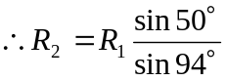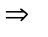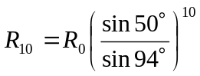



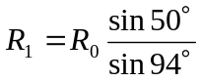

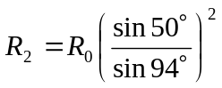


b) Produce a formula in exact terms for R_{n} in terms of R₀.

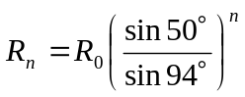


2. [3 marks]

a) From the details given in Part A, describe the flight path of the moth.

Each successive value for R is smaller than the value before, therefore the
moth is spiralling inwards towards the light source.


b) Let R₀ = 20 cm. Complete the graph below for the first six R calculations.
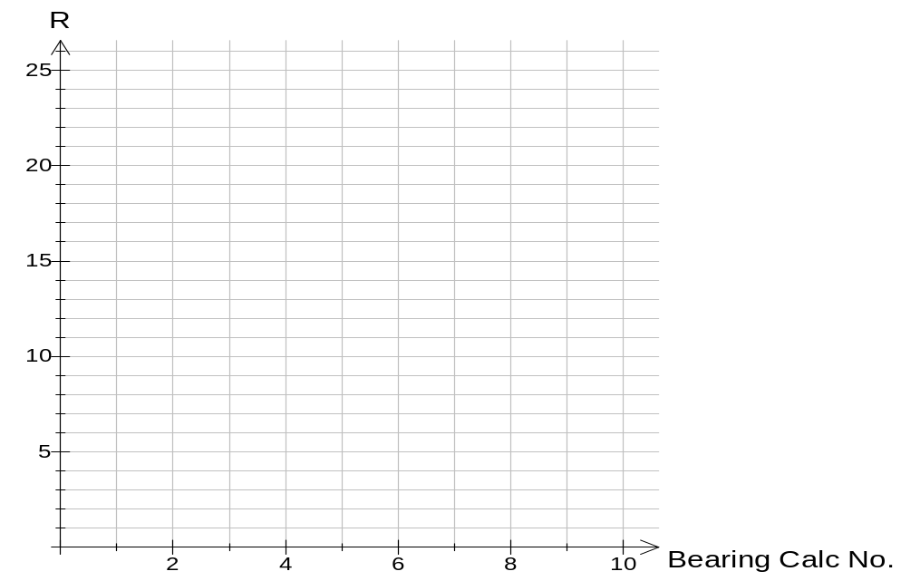

Values are there for the dots to be checked.
15.4

11.8

9.1

7.0
5.3
4.1

3. [5 marks]
a) From the details given in Part A, determine θ , the ‘angle of attack’ which will produce
a circular flight path.
R₀
R₁
36º
θ
θ

10 calculations per revolution,

central angle = 36º, and R₁ must equal R₂
for circular motion.
∴2θ = 144º

θ = 72º i.e. ‘attack angle for circular motion.

b) For what values of θ will the moth spiral inwards/outwards?
Spiral inwards if θ < 72º.

Spiral outwards if θ > 72º.

4. [2 marks]
From the details given in Part A, describe with reasoning what happens when the bearing is re-calculated 5 times instead of 10 times per revolution.

Central angle = 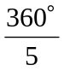 = 72º and attack angle = 50º
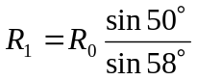. R₁ here is greater than in original situation.


Therefore, it will take the moth longer to spiral inwards.

5. [2, 1, 2 marks]
a) A second moth again flies with θ = 50° but measures its bearing x times in one
revolution. What is the formula for R_{n} now?
Other angle = 180º − 50º − 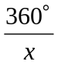 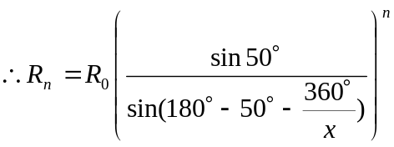



b) Generalise your formula for a moth which flies at a constant bearing of θ° to the light
source and measures its bearing x times in one revolution.

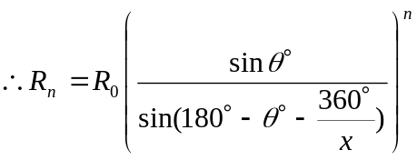


c) Describe, with reasoning, the flight path for a moth where θ = 65° and x = 8

Let R₀ = 10 cm, R₁ = 10 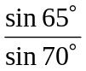


∴ R₁ < R₀ and so the moth will spiral inwards towards the light.


6. [1, 1, 3, 2 marks]
Here are graphs of two moths flying where they re-measure their bearing 6 times every
revolution. R is the distance in metres measured from a very bright light source.

a) How far away from the light source was Moth 2 initially ?

8 metres.

b) The ‘angles of attack’ are 70° and 40°. Identify the ‘angle of attack’ for each moth.
Moth 1 = 40º Moth 2 = 70º


c) Calculate the next two R values for Moth 2, write them down here and
then plot them on the graph above.

R₄ = 8 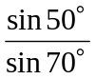 = 18.11 m R₅ = 18.11 = 22.22 m


One for graph

d) A third moth is initially 20 metres from the light source with an ‘angle of
attack’ of 60°. Comment with reasoning on the flight path of this moth.
Central angle = 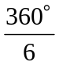 = 60º and attack angle = 60º.


∴Equilateral triangle with R₁ = R₀. So the moth will be flying in a circle.

